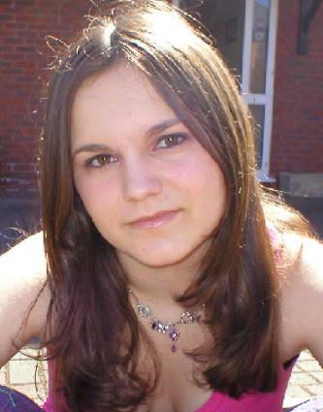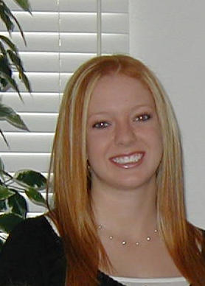
Tiffany Melanie
Age: 23 Age: 22

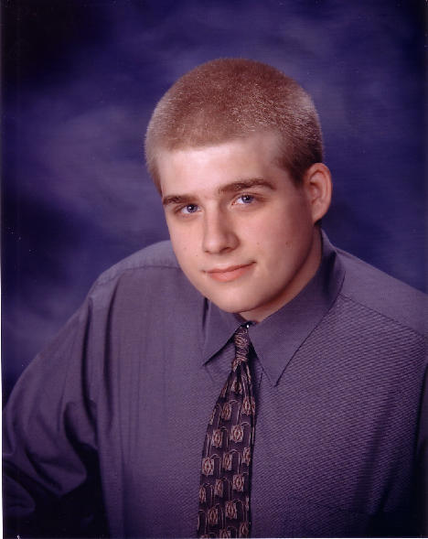

Ian
Age: 25

Part 1

Tiffany was completely lost. Even with the windshield wipers going as fast as they could she couldn’t see though the rain. Yet she continued to drive, much too fast for the conditions. She didn’t know what else to do.
Melanie sat quietly in the passenger seat, a knot growing in her stomach, fear of being lost and Tiffany’s handling of the circumstances. She knew that Tiffany had a hot head, and usually panicked in stressful situations. Melanie glanced back at Ian, her boyfriend. He was asleep, which annoyed Melanie, but then again he had done 90% of the driving so far and he must be exhausted. She wished he was driving now. Melanie decided to say something to Tiffany.
“Ahh… Tiffany, don’t you think you’re driving too fast?”
“Yes!” Tiffany answered angrily.
“Why don’t slow down? Maybe stop to get our bearings?”
“Because I don’t fucking want to!” she screamed.
Tiffany scream woke Ian up. “Wha… What the hell is going on?”
“We’re lost.” Melanie answered.
“NO! We are not lost! We just don’t know where we are.” Tiffany yelled.
“Isn’t that being lost?” Ian said.
“Fuck off.” Tiffany said quietly. Ian looked out the window and saw a sign.
“Exit 89? Tiffany we were supposed to get off on exit 54.”
“Son of Bitch! I knew that but I couldn’t see.”
“We’ll just get off at the next exit and turn around.” Melanie said cheerfully.
Ian grumbled, “Actually, that sign said that the next exit isn’t for another 90 miles.”
“Damn it! I’m turning around!” Tiffany screeched.
“NO!” Ian and Melanie yelled in unison. Tiffany turned hard left to get to the median, but turned to hard, sending the little Isuzu Rodeo into a brutal roll. They skid to a stop on their roof, in the middle of the left lane. Ian and Tiffany were out cold; Melanie was very close to it.
“Ian.” She called out very quietly, too weak to speak louder. She saw headlights drive up to the rolled SUV. She heard car doors close and people walking about. She tried to call out for help but could only manage tiny squeaks. She then she saw a pair of men’s boots appear in her shattered window. He began to speak.
“How many we got?”
“Three, I think.” A woman’s voice answered, “Unless someone was thrown, Simon’s looking right now. Have you seen the skid marks? Gees.”
“Yeah.” The man answered. “That girl must have going at least 80. Can you imagine? In this weather? How’s their condition any way.”
“The man in the back is fine.” The woman answered, “But that idiot driver may have a few broken ribs, her right arm is busted, and her nose is broken. I haven’t checked the girl in the passenger seat. Here comes Simon.” Melanie heard another car pull up.
Suddenly a woman’s face was in the window, looking in at Melanie. She looked Hispanic and was very beautiful.
“Oh dear, she’s awake. Hello dear, we’re here to help you, what is your name? Mine’s Adora.”
“Mel… Melanie.”
“Okay, Melanie I’m going to give you a shot. It will make you feel better.”
Melanie felt the prick in her right arm. Warmth spread though body making the pain dim and fades. A moment latter she blacked out.

Part 2
Melanie slowly woke, looking up into raftered ceiling. This was no hospital. In fact in reminded Melanie of the stable on her grandparents farm, except it smelled much better and there was much less dust. As she looked around the room or stall, or what ever it was called, the similarities with a stable ended. It wasn’t like a stall at her grandparents; the walls were high instead of the wooden boards around a small area. And this room was much larger.
Melanie was surprised to see Tiffany lying in a cot ten feet away. Her right arm was wrapped in a cast and gauze bound tightly around her chest. Melanie then realized that her own left arm was in a cast. She slowly sat up in the cot. It seemed as if everything hurt, her back, her neck, everything. When she finally sat up her head spun. When it finally stopped she called out to Tiffany.
No response.
“Tiffany” she tried again.
This time she stirred.
“You awake”
This time she answered, “I-I think so. God, I hurt.”
“Me too”
Both girls jumped when the big wooden door swung open. Melanie was glad to see Adora; maybe she could answer her questions. She wore very tight blue jeans and tight flannel shirt, revealing her magnificent body. On top of her gorgeous black hair she wore a cowboy hat.
“Oh, it’s good to see you up.” She said, “Melanie, you’re looking better than I hoped. You lost some blood.” She looked over to Tiffany. “How are you feeling, oh, I didn’t get your name?”
“Tiffany. I’m very sore.”
“I’m not surprised. That was a nasty wreck.”
“Where are we?” Melanie interrupted.
Adora sighed, “Let’s see, what’s good way to describe it? About 100 miles west of Grand Junction and 40 miles south of I-70, where we found you.”
“You mean we’re in Utah?”
“Yes, welcome to the San Rafael Desert.”
Melanie was enraged at Tiffany, “Damn it! Tiffany you passed our spot by 100 miles! You stupid little bitch! I’ll…”
“All right! All right, that’s enough!” Adora broke in. She waited until Melanie had calmed down. “Where were you headed?”
“Ian’s brother lives in Grand Junction…” Something hit Melanie. “Where is Ian?”
“He’s fine. Better off then you girls actually, just a knock on the head, he’s in another room going though his own process.”
Melanie didn’t understand that last comment.
Tiffany interrupted her thought. “Can we use the phone?”
“No, I’m afraid not. The storm knocked it out. Why don’t you get some rest?” Adora quickly left the room. Melanie shrugged at Tiffany and lay back down to sleep.

Melanie woke up when she heard a door open. She rolled over to look who it was. At least she wasn’t as sore as she was before. It was a man and she certainly didn’t recognize who it was.
“Who are you?” She asked bluntly.
“Dang,” he stamped his foot, “I was hopin’ I could get in her with out waken’ you up.” He said with accent she hadn’t heard before. “I’m Simon, ma’am, Simon Jorgansen. I am sorry to wake ya up, I did try. Chet wanted me to check on ya both, seeing how nasty that wreck was. I ain’t never seen one quiet like that.” Melanie liked the young man even if he did talk funny.
“I’ve never heard an accent like yours Simon. Where are you from?”
“Aw, hell, nobody knows a Emery County accent. I’m from Castle Dale, Utah, ma’am, right there in the said Emery County.
“Castle Dale, hmm, never heard of it.”
“I doubt many people have. Where you from?”
“CSU. We where going to visit Ian’s brother, Nigel. How is Ian?”
“Fine. Almost done, he is.”
“Done? Done with what?”
“Ahhhh…. Oh! Here’s Ms. Adora!” Adora stepped in.
“Hello, everyone, those casts are ready to take off. Simon, please get Ian.”
Simon looked nervous, “Are you sure Ms. Adora?”
“Yes, He should be ready to move around now, and I’d like to show the girls the things to come.”
“Yes, Ma’am.” He scurried out of the room.
“Tiffany.” Adora gently shook her. Tiffany looked up.
“Time to take off the cast.”
Melanie was confused, so was Tiffany. “So soon? It’s way too early. I’m a med student.”
“We’ve been giving you chemicals that speed up the healing process exponentially. As well as various other things.” There was a knock at the door.
“Come in” Adora called out.

Both Melanie and Tiffany nearly fainted when Simon came in, leading a horse behind him, or what resembled a horse.
“Isn’t he gorgeous?” Adora asked. The horse-thing stood in front of them all, his penis half erect, his nose searching for a scent.
“Sorry about his penis, but Ian is a stallion. Are either of you menstruating?”
“That is not Ian.” Melanie declared.
“Really?” Adora was a little annoyed. “See the tattoo on his left fore leg?” Melanie looked hard, barely seeing it through the fur.
“Oh my GOD! What did you do?!?”
“I am turning him into a horse, like I am with you.” Tiffany broke down sobbing in disbelief. Suddenly another man came in.
“Chet, give Tiffany the injection.” Chet grabbed Tiffany roughly and jabbed the needle into her left buttocks, Tiffany yelped.
“Let’s go, Leave Mr. Horny here, Simon.” With that they left leaving Melanie with the mutant Ian and the insane Tiffany.
Tiffany fell off her cot and groaned. Melanie ran to her and couldn’t believe her eyes. Tiffany lay writhing on the floor. Her jeans strained to hold her swelling rump in. Slowly her pants tore away, revealing her fuzzy ass. A long black tail swished. The rest of her body swelled. Melanie couldn’t look away as her friend’s hands and feet morphed into hooves. Tiffany released a long, wet fart, filling the room with the smell. Her head filled out and soon a small black filly lay on the floor sniffing the air for the stallion that shared the room. Tiffany stood and presented herself to Ian, who was a complete horse now. He sniffed her, and she let loose a torrent of urine. The stallion went berserk, violently mounting the filly pumping his massive organ into her.
Melanie vomited; she could watch her former boyfriend fuck her former best friend. When the pair finished, fear filled there eye. With the lust for sex gone, other feelings entered. Melanie gently stroked the couple’s muzzles.

Part 3

Melanie had fallen asleep after calming the buckskin stallion and the black mare. God, her butt itched. She reached down to scratch and she felt the fur. Oh, no. Then the changes took off. Her rump swelled as Tiffany’s has, her jean tore and a long blonde tail swished about. Her chest barreled out, forcing her neck out. Her hands and feet fused into hooves. She crawled about, new instincts flooded her mind. Her herd! Where were they? Her changing muzzle sniffed for them. Finally she found them. Yes, her stallion and mare. She was safe now. The young palomino filly lifted her tail excreted a pile of manure.

Part 4

Adora looked her new horses. They were perfect.
“Why didn’t he fuck the palomino?” Simon asked his brother.
“’Cause she ain’t in heat, dimwit.” Chet answered, “So, Doc, What do we do?”
“Bring them to the pasture. Hurry up; there was a bus accident a few minutes ago.”
Both Chet’s and Simon eyes lit up.

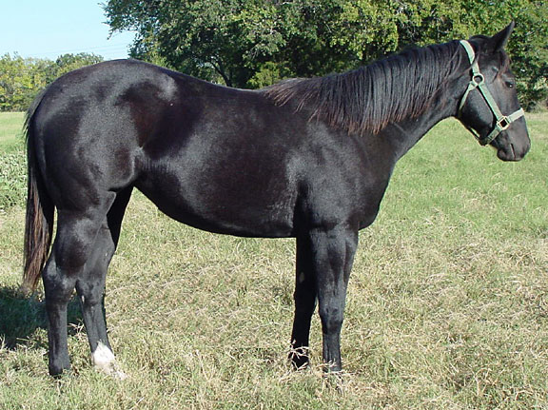 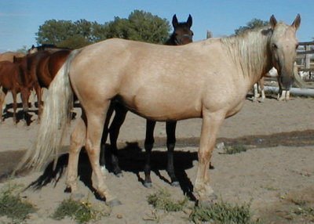 Tiffany Melanie

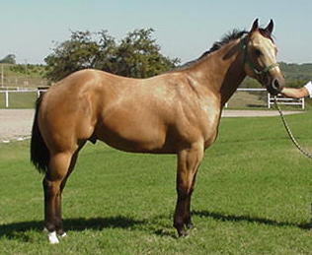
Ian

