Message from the Chairs

Welcome one and all to the inaugural year of Furnal Equinox, Toronto’s first furry convention! All of us on the Furnal Equinox planning committee have been working hard for over a year to bring you something special. Not just another hotel furry con, but something that’s uniquely our own, as only a first con can be.
So…why “Furnal Equinox”? For reasons too numerous to mention, we had the choice of a few weeks around early March or late August, and August was Feral! turf. So March it was, and what’s so special about then anyway? Spring’s just around the corner for one thing, beginning at the vernal equinox (March 20th). That was marked by the pagan celebration of Oestra (later becoming Easter), a time of celebration and rebirth. So what better than to name the first con of spring…the Furnal Equinox!
The perennial focus of our event will always be spring and fun, with a unique Canadian twist. We’ll also pick a new theme for each con, and this year’s is “Furry Fun and Games”, inspired by the Olympics which were held in Vancouver last month. The world gathered for two weeks of friendly competition and celebration, and we’re going to do that spirit proud with our own furry tribute. There’ll be unique furry sports, video and table gaming, and plenty of other activities everyone can participate in. We’re doing our best to make this one of the first “24-hour cons”, with an all-night dance/rave, zoo, and video gaming to tempt you to see how long the sandman can be kept from the door! Coffee, anyone? Tim Horton’s is just across the street!
We’re also privileged to have a stellar pair of Guests of Honour, well-known furry artists Heather Bruton and Bushycat, whose art graces our conbook covers. Their styles differ, but they’re both well-known and have a long history in the fandom, including local connections. Be sure to drop by the Dealer’s Den to say hello, and don’t miss their panels. Speaking of those, we’ve assembled quite a set of seminars, covering topics from art and writing to furry history, and all points in between. A good excuse to use when someone asks “So what did you learn?” We all know that’s why anyone goes to conventions, it’s so educational! Nothing to do with fun, oh my no. Sure it doesn’t…*cough* room parties *cough*.
With the obligatory “Oh wow, I’m so excited!” part of the introduction out of the way, it’s time for the part the chairs really like: talking about the state of their spleens. Right now it’s “tired but happy”. Organizing any con is real work, but a new one is doubly so, because everything is new territory. There’s so much to be created out of nothing, among them a name and perennial theme that will make the con unique yet reflects those involved. There’s assembling a committee and staff that will work together through good times and bad, who can rely on each other to get the job done. It takes a certain type of team to step boldly into the unknown, to take a chance on a distant vision, and to persevere through the ups and downs, and it’s been an honour to work with our concom and staff.
We couldn’t have gotten this show on the road without good mentors to explain the way forward. Many of the new US cons are mentored by Uncle Kage, and we’ve got our own local version in Potoroo, the chair of one of the longest-running and most unique conventions anywhere, Feral! Roo, thanks for all the advice, and here’s hoping that Furnal Equinox can run as many years as Feral has: 13 years this summer.
Cons tend to come and go over the years, and since Feral! started the Canadian con scene, furries have been served by Ottawa’s C-ACE and Montreal’s Anthrofest. But Toronto has never had a con of its own, despite having the largest furry community in Canada and being only a few hours drive from the US furry hotspots. That drought is now over, and 2010 also sees the debut of two other Canadian furry cons: Condition Furry in London and What The Fur? in Montreal. We’re proud to say that all the Canadian cons are supporting each other in many ways, and that’s how it should be.
Finally, we’d like to thank you all for being part of this event, by attending, volunteering, or helping support the artists. We can’t put on events like this unless you show up, and it’s not worth it unless you’re enjoying yourselves. So go out there and have fun, and try something new! Drop a little coin on a hotel room and experience a con the way it’s meant to be, dance all night till your paws are sore, or take part in one of the games. And don’t be afraid to stop the chairs or staff and let them know you’re having a good time; we’ll appreciate it more than you know. And if you’re inspired, talk with us after the con—there’s next year’s event to work on and we’ll need your help!
So let the games begin!
- Pakesh De (bear accepts bribes of cola!)
- Blindsight (the dancing alpha wolf)
Co-Chairs, Furnal Equinox 2010

GOH: Bushycat

A Furry artist for 13 years, a cartoonist and catlover since birth, BushyCat is a common fixture at Furry conventions across the United States. She hails from the currently very wet wilderness of upstate New York. Surprised by recent heavy flooding, much of BushyCat's attention is currently focused on the removal of lots of high-quality mud and an excess of stranded crayfish from her cellar, workshop and grounds. Fortunately, there was time to move most important belongings above the level of the floodwaters. A move to higher ground is currently under consideration.
When not dodging floodwaters and fanboys, BushyCat spends her time painting, drawing, sewing costumes and creating fun Furry art. She has recently begun painitng large-scale canvases and constructing plush novelties. The slightly dampened workshop holds an impressive stash of painted wooden animals, with more projects awaiting better drying conditions. She also dabbles in classic pin-up art and is currently taking commissions for furry artwork of all kinds. Better Busy than Bored!
BushyCat's favorite non-art related pasttimes include: reading mysteries, watching anime, experimental cooking, camping out, and spending quality time with her mate.
She shares life with her human family and 4 cats; Tammy Tiger, Purrdita, Claudius and Kuro Neko Chan. Claudius writes and posts his own blog on a whenever-he-feels-like-it basis.
BushyCat's art can be viewed at: http://www.thevioletpanther.com
Claudius' blog can be viewed at: http://www.misterclaudius.blogspot.com
email: YoroidenGi@aol.com

GOH: Heather Bruton

Heather was born in Halifax, Nova Scotia and currently resides here in Ontario. At her first SF convention in 1978, she won two art show awards for her work; the first of over 150 that she has laid claim to since. In the early 1990s, Heather began to work in the gaming industry, producing art for a myriad of companies, in addition to her work in the science fiction, fantasy, and furry genres.
A regular presence at furry conventions, Heather remains critically acclaimed in the furry fandom. She was previously a guest of honour at Anthrocon 2002, and has been nominated for an Ursa Major Award in the category of "Best Anthropomorphic Published Illustration" for two years running in 2007 and 2008.
You can find her work on FurAffinity as well as on her official website, heatherbruton.com.

Restaurants/Area Map

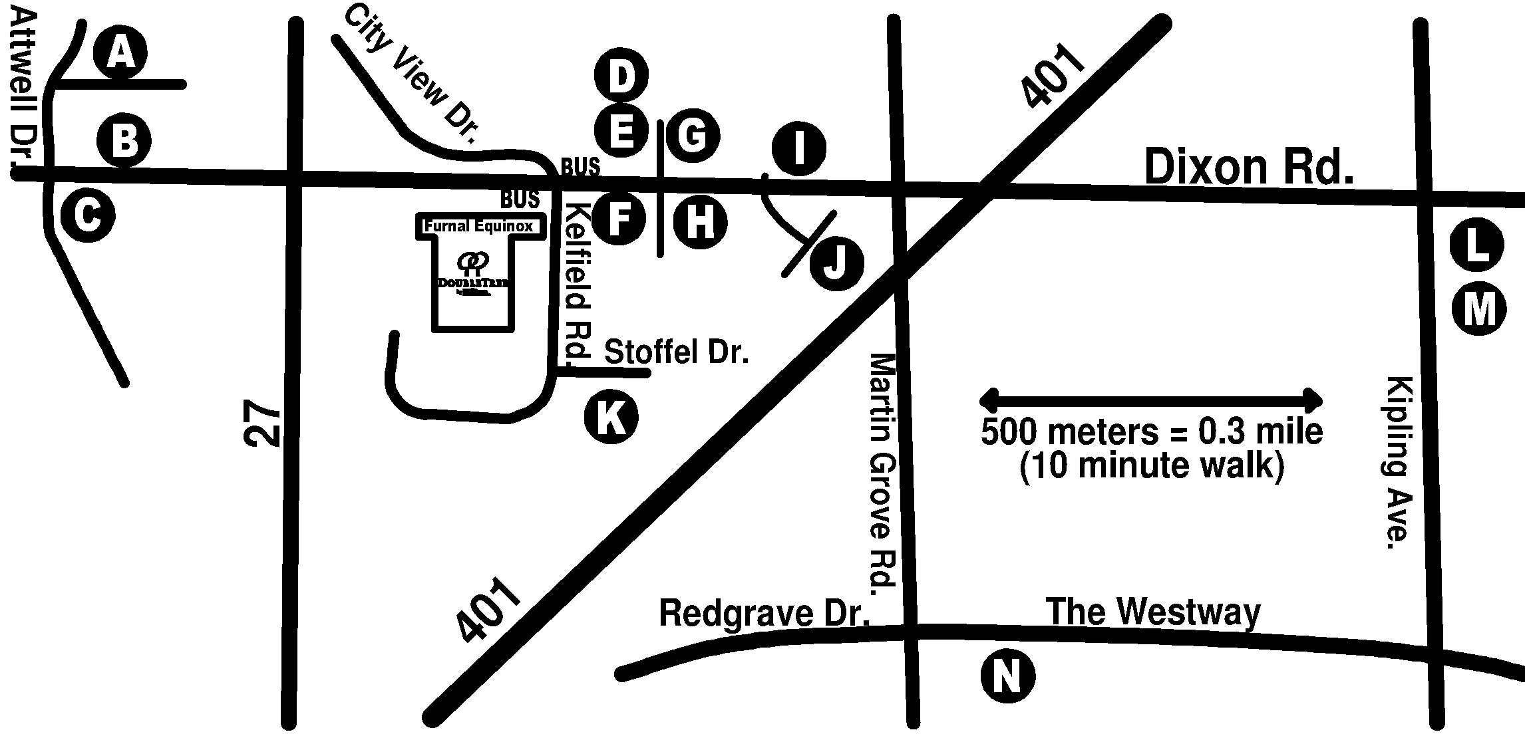

Due to the superfluity of useful local locations, a number of letters indicate multiple spots of interest. There are four restaurants in the hotel; they do not have letter codes.
 A discount is available for con attendees. Most just require your conbadge, a few require picking up a coupon at conops. See the description for details.
 Transit stop
 Food and drink
 Gas stations
 Printing and Photocopy facilities
 Go carts
 Beer and alcohol. Note that in Canada alcoholic drinks are only available at designated locations. The legal drinking age in Ontario is 19. Please drink responsibly and don't fursuit while drunk!

Restaurants In the Hotel
Ginko's
Open Sushi concept. Elegant dining at elegant prices.
Sat 5PM-10PM, Sun 5PM-9:30PM
Price 20-50$ and up.
Grand Chinese
High end Chinese dining with swanky decor
Sat 10:30AM-10:30PM, Sun 10:30AM-10:30PM
Price 15-30$ and up
Orchid Cafe and Wine bar
Everything from burgers to pizza pizza of all things. Relaxing lounge too!
Sat 6AM-10PM, Sun 6AM-10PM
Price 10-30$ and up
Alfredo's
Italian food and Mediterranean as well. Very high class and exotic dishes.
Sat 6AM-10:30PM, Closed Sunday
Price 15-30$ and up

Restaurants
A Tony Romas famous Ribs
Name says it all. Expect the bill to be as meaty as the food.
10 Carlson St. 416-674-8488
Sat 11:30AM-11PM, Closed Sunday

Price 25-50$
B Boston Pizza
Sports and pizza place and bar. Good food, decent sizes, good selection.
5 Carlson St 416-679-9320
Fri/Sat 11AM-2AM, Sun 11AM-1AM

Price 15-25$ each (15% off with badge)
B Jack Astors
Sport bar and eatery. A little pricey but very popular for sports viewing and higher end food.
25 Carlson St 416-213-1688
Sat 11AM-2AM, Sun 11AM-1AM

Price 12-25$ (15% off with badge)
B Tuckers Marketplace
All you can eat country buffet. Cheap prices, huge selection, worth the short walk.
5 Carlson St 416-675-8818
Sat 4-9 PM, Sun 11:30-4, Dinner 4-9PM

Price Lunch 17.99$ Dinner 22.99$
B Canyon Creek Chophouse
Steak shop and eatery. Nice and comfy. Good choices for a hungry stomach.
25 Carlson St 416-213-1162
Sat 4PM-1AM, Sun 4PM-11PM

Price 15-25$ (15% off with badge)
C Olio-o Mediterranean Grille
Interesting dishes for the more adventurous diner. Why not try it out?.
Location 801 Dixon Road 416-675-6100
Sat/Sun 6AM-10PM

Price 25-50$
C Montana's’Steakhouse
Steak and more. Good prices, just beside the Olio. Nice selection and lovely food
801 Dixon Road 416-679-2925
Sat/Sun 11:30 AM-11PM

Price 15-25$ (10% off with badge)
D Tim Hortons
Timmies for your 24 hour sugar fix!
638 Dixon road 416-242-6097
24 Hours

Price 5-15$ if you really need coffee and a box of doughnuts
D Subway
Subway eat fresh.
642 Dixon road 416-240-9000
Sat 7AM-3:30AM, Sun 9AM-1AM

Price 5-15$
D Swiss Chalet
Sit down large friendly place. Cheap prices, good portions if you like chicken.
642 Dixon road 416-614-2502
Sat 11:30AM-10PM, Sun 11AM-9:30PM

Price 10-25$ (free appetizer with coupon)
E Harveys
They make a hamburger a beautiful thing.
648 Dixon road 416-244-1841
Sat 10:30AM-11PM, Sun 10:30AM-10:30PM

Price 5-15$ (10% off with badge)
E The Fox Bistro
Bistro. Small menu but nice place inside.
640 Dixon road 416-243-7912
Sat/Sun 7:30 AM-10PM

Price 15-25$ (15% off with coupon)
E Milestones
Nice family place. Steak and such. Decent prices and staff.
646 Dixon Road 416-245-6262
Sat/Sun 10AM-10PM

Price 15-30$ ($5 off with coupon)
G Sushi Dragon
Expect spicy types of sushi. Not too expensive like all sushi places this time of year but tasty.
634 Dixon road 416-248-6666
Sat/Sun 11:30AM-11PM

Price Lunch 15$ Dinner 20$
G Kelseys
Another family eatery. Good but more selection but costing more then Chalet.
636 Dixon Road 416-240-6932
Sat 11:30AM-Midnight, Sun 11:30AM-11PM

Price Lunch 15$ Dinner 20$
H Mama Panino
Italian eatery. Cheap and filling for what it has. Just renovated and all new menu
621 Dixon Road 416-244-4344
Sat 11AM-10PM, Sun Call Ahead

Price 10-25$
H SushiYa Japan
Sushi and whatnot. Small size but large menu
585 Dixon Road 416-249-9666
Sat 11:30AM-10:30PM, Sun 4PM-10:30PM

Price Lunch 15$ Dinner 20$ (10% off with badge)
I Perkins
Inside the Holiday Inn hotel. Good solid eatery and nice folks.
600 Dixon Road 416-240-9741
24 hours

Price 10-25$
J St Louis bar and grill
Chicken and ribs most likely a few beers on tap too. Medium range selection foodwise.
577 Dixon road 416-248-5622
Sat 11AM-2AM, Sun 11AM- Midnight

Price 12-20$ (15%0ff with badge, 2 free appetizer if you reserve for party of 10)
M McDonalds
The golden arches. The golden sign of cheap fast grub.
Westway Shopping Centre (Dixon and Kipling)
Sat 7am-11PM, Sun 7am-10PM

Prices 5-15$

Other Locations of Interest
E Bus Stops (Dixon #85)
TTC bus shelters right outside the hotel. Runs between airport and Lawrence West subway station.
Generally runs 9am-1am on weekends, but check TTC website for full information.
E Dixon Convenience Store
ATM, snacks, drinks for cheap
648 Dixon Road 416-245-8533
Hours of operation 8AM-9PM weekends
F Shell Gas Station
Right across from the hotel.
H Petro Canada Gas Station
East on Dixon.
J Print Three
All your printing needs in one stop.
557 Dixon road 416-246-9803
Sat 10AM-5PM, Sun Closed
K 401 Mini Indy Go-Carts
Have some fun racing indoors! Has beer, food, lounge. Nice place and short walk too.
37 Stoffel Dr. 416-614-6789
Sat Noon-11PM, Sun Noon-10PM
Price 50 laps/49.99, 80 laps/69.99 (Party of 8 req’d)
Smaller groups must share track, call for rates.
Food: 15-27.99$
L The Beer Store
Boozing goodness. Drink responsibly
19+ years of age, Government photo ID required.
Westway Shopping Centre (Dixon and Kipling)
(416) 244-8522
Sat 9AM-9PM, Sun Noon-5PM
N LCBO
Booze of all kinds! Drink responsibly.
19+ years of age, Government photo ID required.
415 The Westway (416) 247-7131
Sat 9:30AM-9PM, Sun Noon-7PM

Programming and Special Events

SPECIAL EVENTS
Closing Ceremonies
Dances/Fursuit Dances
Dead Dog Dance
Fursuit Parade
Fursuit Photography
Meet the Guests of Honour
Opening Ceremonies
PANELS
Animal Drawing:
Host Kent Burles
This workshop will give you an intense exposure to garden variety animals such as cats and dogs. Kent will be working with you step by step for simple yet accurate anatomy to help you draw with confidence.
Creating Comics:

Host: Kent Burles
If you thought the animal drawing course was intense, then wait till you experience the unbridled ferocity of the 45minute crash course in drawing comics. (20min for questions afters)

Female Furries

Host: Roz Hart
Tired of feeling like the only female furry? Then this panel is for you. Come out and discuss Life in a male dominated fandom, what we can get out of the fandom and what we contribute. Males are welcome!

Furry Literature Q&A
Host: Phil Geusz
This panel is your chance to ask questions about the furry art where the canvas is the reader's mind. Veteran furry authors (insert names here) will be on hand to field questions about what makes fiction furry, the state of the furry publishing industry, how to grow as an author, how to get published... Basically, anything you want to ask, we'll try and answer.

Head Building 101

Host: Thadius Effingham
Come and learn tricks and tips from other fursuit builders. Have a question? Our panel will do their best to point you in the right direction. Not everyone has a fortune to spend on their suit so come and learn when you can find common household materials and cheap supplies that work. How to build a wire frame? Install a fan? Different types of heads for different reasons.

History of Furry
Host: Pyat
In a sense, “Furries” have been a part of the human imagination for as long as stories have been told. Neolithic cave paintings depict half-human, half-animal creatures. The earliest civilizations worshipped gods with animal features, and told tales of animals with human souls. But, how do funny animals and fit into this heritage? Is there any connection at all? This panel discusses the history of "furries" in culture, as well as the history of the modern fandom.

Intro to Fursuiting

Host: Galaxy Snow
Are you a first time fursuiter? Do you need a little guidance on how to get around the con, and things to make the most of your convention experience? Come and join our orientation for first time fursuiters, and learn what to do, and what not to do.

Legendary Creatures

Host: Scani
Dragons, gryphons, nagas, cockatrices, manticores, phoenixes, garuda, the list goes on... History and mythology remembers these creatures as some of the fiercest enemies and strongest adversaries you could ever come across! If you are one, or you just happen to be a fan, come on out, share your experiences and discuss the art and writing that's inspired you!

Rodents!

Host: Charles Matthias
Gather round all ye rats, mice, beavers, squirrels, chipmunks, and others with pronounced incisors and a craving for some good chew! This is a time to celebrate our fellow rodents, share stories, art, and fursuits, and meet those of us who share this love of our little brothers and sisters.

So this is your First Furry Con?

Host: Linnaeus
Is this your first furry convention? Are you feeling a little overwhelmed and aren't sure where to start? This is the panel for you! Learn what to do, what not to do, and make sure you survive FE!

Transmutational Transcontinental by Phil Geusz

I spent hours poring over the rules, looking for loopholes, errors, and inspiration. Such a large purse was well worth a little study. But this year's Classic regulations appeared entirely bulletproof. It looked to be a straight run for the money. Damn! I’d won quite a few easy victories in the past by outhinking race committees, but they were learning. This time, it looked like if I was going to keep my champion status intact I’d have to do it the hard way.
And I hated the hard way. It was far too much work.
The year's biggest event was a toughie— New York to San Francisco by paw, hoof, or whatever, racer's choice. The racer sets a course for himself, the racer chooses his form for himself, and the racer takes his chances for himself. All the transcontinentals work like that. There was a separate seaborne event, but I didn’t particularly care for cetacean life. Besides, the big money and fame were always to be found via the traditional land route. And, I have to admit, it’s a lot more fun waging a battle of wits than just flailing one’s flukes for hour after endless hour. Seaborne competitions are more tests of endurance than anything else. Land races, however were an entirely different story. Humans have always raced on land by every available means of transportation. Cars, carriages, pogo sticks… If you can make miles with something, it’s been raced. Most likely with great intensity and enthusiasm. And when transmutation technology became widespread and cheap, new forms of racing quite naturally followed along almost immediately after. At first it was human horses, but soon it was cheetahs, pigeons, hawks, frogs, whales, gorillas...
You get the idea, I’m sure.
And since the sport was a natural for tridee, the competitions quickly became intense and frequent, with big money and endorsement contracts on the line almost weekly. A big name transcontinental racer like me, well, I rarely had time to become human between events anymore. Even as I prepared for the Second Annual North American Classic, I was still wearing the jackrabbit’s body that’d carried me to a very respectable second-place finish in the Outback Dash. The winner made the obvious choice of camel form, as did the third, fourth, fifth, sixth, seventh, eighth, ninth and tenth-place finishers. I thrive on not choosing the obvious and succeeding anyway, and the second place finish kept me well up in the point standings for the year. Besides, the sponsorships tend to be much more lucrative when you pick a different animal than everyone else. Especially one that might not live through the event, given natural predation, unless the racer is a very skilled and experienced survivor indeed. Which, of course, I am. To my opponents’ continual frustration and dismay. At the finish line of the Outback, I actually drew far more media attention than the winner.
Carefully, I used the pencil in my mouth to press the "page back" key on my perscomp and reread the rules yet again. The race was to run from the foot of the Empire State Building to the Golden Gate bridge. Except for defined paths through the cities at both ends of the course, travel by road or rail right-of-way was forbidden, though the racers were free to choose any other route. Competitors must live off the land entirely, and must not have any contact with humans excepting media filming en-route. Sign-reading was allowed- one could hardly avoid it, after all. And water and shelter were where you found them. But otherwise, racers were forbidden from utilizing any human infrastructure. Bridges must not be used, for example. It was pretty much the standard package, these days. Basically, we’d be required to entirely live as our chosen species for the duration of the event. Not even speech was permitted.
This particular event was at least relatively open in regard to permissible forms. I could compete as any mammal, reptile, or flightless bird known to have existed in nature in the year 1900. I smiled at this last requirement, or would’ve smiled were a jackrabbit’s face designed that way. Last year I’d taken advantage of the "any reptile" loophole to become a pterodon with a forty-foot wingspan and win the first annual event in an easy glide...
But it wasn't so easy this time around. Try as I might, I could find no way to cheat the system. Sighing quietly-- hares sigh very quietly, if they wish to avoid becoming something’s dinner-- I turned off the perscomp and laid down on the carpet. Trying to read the screen through jackrabbit eyes was giving me a headache, and I wasn't learning anything new.
Picking the winning form is the key to winning and making money. Everything else is secondary, and driven by this most important of all choices. A competitor has to be able to easily find food, escape predation, and travel quickly through the various terrains and biomes. But this event was unique in that there were so many biomes! First there came the East Coast suburbs, then the cornfields of the Midwest, the plains, the Rockies and lastly the endless desert beyond. It was awesome to contemplate. A competitor could (and sometimes did) end up starving, being eaten, falling off a cliff, drowning, getting shot, or even end up as road kill. And weighing these issues was just the first step—after that, it was time to think about winning!
Personally, I always worried most about the river crossings. The problem is that there are far too many big river crossings. The only way around them is to select a far-north routing to get around the Mississippi system. Personally, I figured that just about all of my competitors would choose that route rather than face the very real possibility of drowning. Just like it was also a pretty safe bet that almost everyone else would choose some long-legged deer or equine or perhaps even antelope form to compete in. That way, finding food would be relatively easy and long-distance running natural. Which in turn meant that these options were closed to me. I had a reputation for originality, after all.
A cougar, perhaps? No, predators never worked out. Hunting took too long.
Hmm....
A buffalo, perhaps? I’d have no predation worries, and the advantage of being in natural habitat practically all the way. And the good ol' American Bison could make pretty decent time too. I'd have to avoid the river crossings like every one else, though...
Nah. Not original enough. Let the also-rans take that route. Victory was to be found in figuring out a way to both take the most direct route and move quickly...
What about that Chinese water buffalo I'd once read about- the one that was bred long ago to pull small barges in canals not by walking along a path the way any sane person would arrange it, but by swimming? This form could handle the river crossings sure enough, but would be slow, slow, slow overland...
Close, but no cigar.
It was really too bad about those rivers. If it weren't for them I'd have been half tempted to remain a jackrabbit. I was well adapted to being a hare, and it suited me psychologically as well. I could avoid time in the tank, freeing me up to do more extensive route research than any other competitor. The ones I was really worried about were all still camels at the moment and would certainly have to change forms in order to meet the demands of North America. The jackrabbit form was good for covering ground in a hurry, and easy on water. Food was a snap, too. Even in the Australian desert I'd eaten decently. While I'd be out of my natural habitat part of the way, my form would at least be pretty close to the native lapine varieties for the entire route. What with the race being held in warm weather, my form could survive easily anywhere on the continent.
Except in the rivers. I felt a sense of deeply-rooted dread at the very idea of facing all that water as a hare. There were limits to the risk-level that even someone as crazy as I was could accept, and that one was well over the limit. We competitors all had built-in panic buttons and tracers, of course, but a bunny in a big river can drown awfully fast...
Hmm....
Idly, I gnawed at my pencil. Raccoons could swim. And they were native almost everywhere too. If a racer’s chosen species survives in the wild in a region, he or she can be pretty certain of finding enough to eat there. And I just might manage to handle the Big Muddy as a 'coon. But could I cover the rest of the distance fast enough? I had a deadline to beat, one set by galloping horses and swift deer...
No. I’d be far too slow, even with the others traveling further. Damnit.
Well, then! Perhaps I could use all that water to my advantage? What if I took some sort of otter form? I could swim most of the way, using the Ohio, Mississippi and Missouri as highways instead of having them act as barriers. And that wasn't even looking at the minor streams that might allow me to work closer still to my goal. After all, the West slope of the Rockies was pretty wet- probably the only long distances I’d have to walk would be over the Divide itself, plus a few other little stretches here and there. I could fish as I traveled, live predator free, and let the current help me along a good part of the way...
And have the current work against me for an even larger part. Plus, travel all the curves of the rivers instead of having a straight shot.
Hell and damnation!! This was tough!
Thinking back, I remembered last year's contest. Before I ever left the starting line, I’d picked out a series of cliffs and river bluffs to overnight on. In the mornings, I’d simply let the warming morning air lift me effortlessly to altitude. Then all I had to do was to glide west to my next roost, expending little to no effort along the way. My reptilian metabolism had been extremely efficient, though I was forced to hunt a bit from time to time. A pair of deer along with some carrion here and there had seen me through. And carrion tasted just fine, when one was a pterodon. The rivers had been nothing, no trouble at all...
Which was precisely why the officials had ensured there would be no flying forms this time around. A winged species was cheating, in a way...
Then I blinked. Wait a minute...
Carefully I checked the rules again. No species extinct before 1900. Avian forms were allowable, but must be flightless. Reptiles were also legal And all mammals...
I stood up on all fours and kicked my hindlegs in sheer joy, then frolicked to and fro about my apartment as I poured out my feelings in the only way my voiceless state would allow. I had them, had them, had them! I was going to win again, And nothing could stop me! They’d left another loophole!
Finally I calmed down and got back to work. After kicking the air one last time for the sheer joy of it I headed back to the study. I had it, damnit! Had it for sure. My heavy breathing rendering my pencil a bit unsteady, I powered up my perscomp and settled in to do a little research.
What kind of bat I was going to be? I couldn’t wait to find out!

Maps
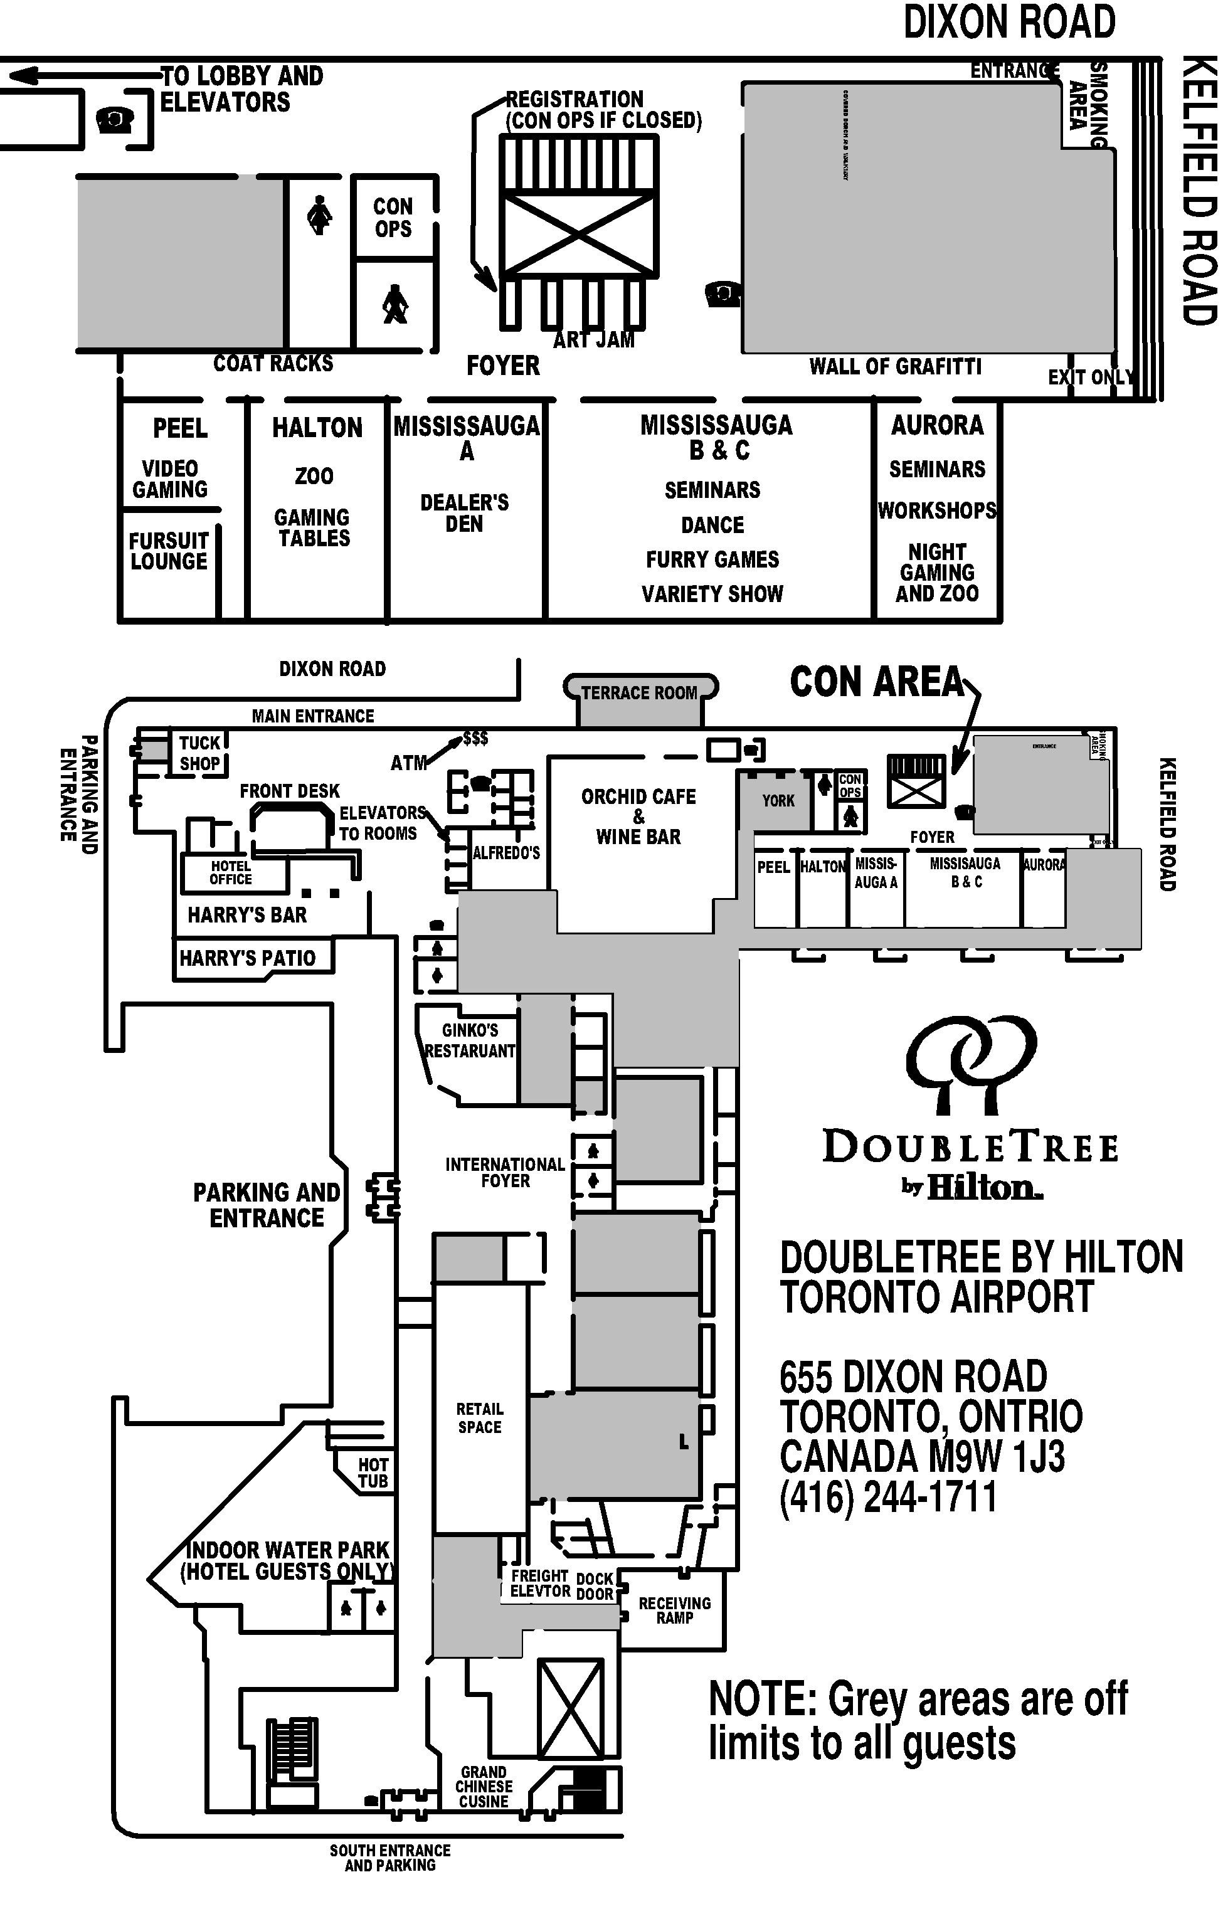
The Rules by Charles Matthias

"Fine!" Mikkel the Rottweiler sighed at his two fox friends. ~"We'll play Hide'n'Seek. But here's the rules! No leaving thejunkyard, no going into my house, and no climbing into any of the machinery. Some of it's dangerous! Now I'll count to fifty then sniff you out!" Nolfi and Ardas wagged their tails and then darted off through the mounds of scrap as Mikkel began to count.

"Here, Nolfi!" Ardas suggested to his older brother. The young kit gestured to a shadowed alcove within a stack of drum barrels. Nolfi shook his head. "Too obvious." He scanned the many similar piles of junk until his eyes happened upon an old derelict coated in rust and neglect. "There!" The two kits raced over, the scent of oil, grease, and other fouler things surrounding them. They came up short before the house sized machine. "But that's 'gainst the rules!" Ardas objected as he took a step back. "An' it stinks!" Nolfi replied with a barking laugh. "Perfect!" He pointed to a hatch at the rear of a long enclosed section. "Go in there, I'll climb into the front." "I dunno..." "Hurry!" Nolfi pushed him toward the hatch. "Mikkel's almost done!" The young kit climbed through the hatch and pulled it closed behind him. A little click sounded, but Nolfi paid it no mind as he climbed into the control seat at the front. Levels and knobs protruded from a panel recently scrapped free of rust. Nolfi curled into a ball on the floor, and waited, ears perked.

"Fifty! Ready or not, here I come!" Mikkel shouted and then started sniffing. He'd only started fixing stuff up in the junkyard when his Dad went off to the war a few years back, just like Nolfi and Ardas's Dad. But he'd long grown used to the usual scents and had no trouble picking out the two foxes. He bent down, overalls and nose brushing the ground and followed their trail, walking on all fours.

Nolfi kept his ears perked and listened to the distant sound of Mikkel snuffling around the ground. He grinned and put both paws over his muzzle to keep from laughing. It had taken them a week to wear down the Rottweiler, but they knew he'd eventually give in. He always did. Their father probably wouldn't like them playing with a Junker, but he was the only pup their age. The rest were old enough to work the fields or still supping teats. Besides, there was so many cool things to play with in the junkyard! Nolfi glanced at the array of controls over his head, and after checking out the door but not seeing Mikkel yet, he began shifting levels and pulling knobs. To his great surprise, the machine lurched beneath him, and a heavy grinding noise started behind him.

Ardas didn't like the inside of the derelict. The hatch led into a long sealed compartment with narrow slits at the top that let in light, and a larger hatch that was also closed. Grillwork blocked the opening behind him while the far end was filled with an intricate series of drillheads, nasty, coated by rust, but still looking sharp and menacing. He shivered as he gazed at them, wishing that it had been Nolfi who'd climbed in here instead. He hoped Mikkel found them ~soon so he could get out. And then a loud clunk shook the chamber, and the drills began to spin, rust grinding away as the machine sprang to life. Ardas gasped, tail and fur stiff, and then dashed to the hatch. He pushed but it held fast. He tried to handle but it was stuck and coated with rust. The little fox kit fell back against the grill work and screamed, warmth filling his trousers. The drill bits ground closer.

Mikkel was sniffing around a set of iron barrels when he heard the sound of the old junk grinder come to life. He'd been working on repairing it for the last few months as once it was fully working it could save him a lot of time and help get the junkyard looking the way it had when his Dad and his Uncles were running the place. The Rottweiler leapt to his hind paws and bolted through the junk dunes. He saw Nolfi frantically pawing at the controls, but there was no sign of Ardas. Mikkel glowered, leapt up next to the fox and stared at the levers. They were all a mess. "Sorry, sorry!" Nolfi stammered, eyes wide and tearing. "Ardas is back there!" Mikkel's heart tightened, and he tried to remember how the levers were supposed to be positioned. It took a few seconds, but once he knew, he put them back in order, and pushed all the knobs in. The powerful drill chugged one last time, and the floor leapt an inch, knocking Nolfi on his tail. He took a quick breath, jumped to the ground, and ran around to the hatch. He hadn't gotten around to fixing the faulty latch on the door yet. He took out his wrench and beat on the handle a dozen times before with a metallic screech it popped open. The hinges protested with a squeal as he yanked the hatch back. Standing with his back pressed to the grill, golden eyes wide, tears streaking his white-furred cheeks, and a pungent stain coating the front of his pants was Ardas. The drill-head hunched two arm lengths from his face. Mikkel helped Ardas climb out and then set him shivering on the ground. Nolfi fell at his side and apologized as he cried. The Rottweiler shuddered and hugged them both. "I told you not to hide in the machinery!" Mikkel barked, both angry and relieved.
The two kits yipped, holding each other and Mikkel. "I'm so sorry!" Nolfi cried. "I'll never break the rules again!" "Me either!"
Mikkel sighed and hugged them again. "That's why there's rules!"
Neither fox would ever break them again.

Gamemastered Events at FE

Encounter at Albequrque
System: Game Gamma World
Players: 4-8 (characters provided)
Sat noon-3PM; Sun noon-3PM
GM: Fulminar
A party of lost and hungry adventures seek shelter from harsh weather, and even harsher monsters when they stumble into the desert. Off in the distance something looms to lure the brave party closer to salvation, or certain doom? It's all in your hands as you make the choice to stay outside with the storm and critters or advance to fate.

The Eye’s Have It
System: D&D 2.0 (furry edition)
Players: 4-8
Adventure Levels: 8-10 (bring your own character or use supplied characters; no magic items over +3.
Sat 8pm to 11pm, Sun 8pm
GM: Silvax
A little town outside of Waterdeep is having issues with people, animals and things disappearing. The local Militia is having no luck figuring it out. There are no tracks and no cries of attack when it happens. There are many caves in the area, and way too many for the local Militia to guard. They have requested help to check the caves out fully once and for all. Do you have the fortitude and will to check out why and what is happening? Does your local religion talk about anything here or near here? Why is Waterdeep not sending any help, but you adventurers? These and many other questions go through your head as you find yourselves a mile away from the city, and the caves.

The Fur Within
System: Werewolf the RPG
Players 4-8 (characters provided)
Sun 5PM-8PM
GM Manlantrio
You have finally passed the trials and have reached adulthood within the Cairn. Now comes the responsibility that your new rank holds. As you sleep a spirit enters your dreams and says to you "The Childe of white approaches but darkness dances over him dogging his steps. At the revel of the artisan kin the Childe will either choose be found or lost forever.

Meet Professor Ostler
System: Ironclaw
Players 1-4+ (characters provided)
Saturday from 2-5PM
GM: Pyat
The gates of Triskellian lie ahead, your final destination after a long and dusty journey. But, a chance encounter with a travelling medicine show man delays your arrival... and offers the promise of danger, intrigue and great reward!

The Shrine and the Goblin
System: Usagi Yojimbo
Players: 1-4+ (characters provided)
Sunday from 2-5PM
GM: Pyat
The Nakasendo Way from Edo to Kyoto has long been the path of merchants and pilgrims. In these more troubled times, long stretches of the road remain desolate, and travelers are wise to go in groups. You are such a traveler, and though the way has been quiet so far, you remain wary. While bandits are a constant danger, others speak of darker dangers, of ghosts haunting the Sekigahara Battlefield, and demons hiding in the shadow of the mountains….

Under a Blood Red Moon
System: Werewolf the RPG
Players: 4-8 (characters provided)
Sat 5PM-8PM
GM: Arnimal
This time the Kindred have gone too far! A Blood Hunt is called and you, the Garou, are to be the targets! Can you survive when a city worth of bloodsuckers, Black Spirals, and its allies come after a treasure almost beyond price? Only you can change the fate of what might forever be known as the blood moon massacre.
Two Legs Bad, Four Legs Worse?
System: Teenage Mutant Ninja Turtles
Players: 4-8 (characters provided)
Float game in case of need
GM: Pakesh de
You all signed up for some simple easy lab work. Easy pay, six month secluded vacation in the Canadian north. Isolated, roomy quarters, well fed, what on earth could go wrong? You will soon learn to regret those words one fine morning after an extra spiked dinner with the other volunteers! Can you think on your feet? Do you crave the outdoors? Are you willing to bet your life on it? ☺

Winter’s Magic by Laura Laakso

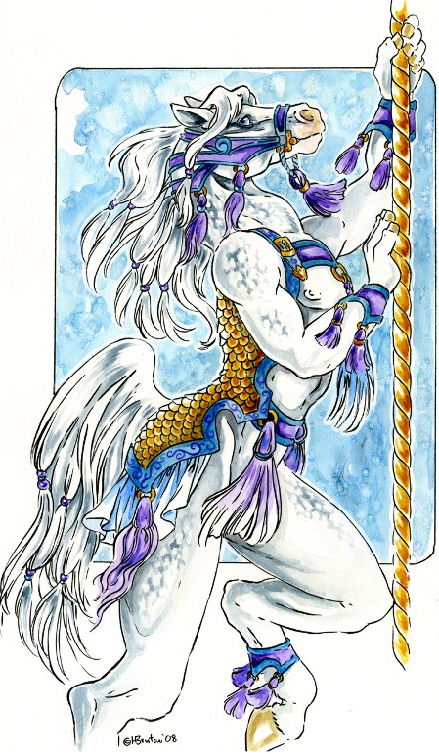
It is that time of year again. I can smell the falling temperature in the air and the forest is carpeted in a rustling, multi-coloured blanket of leaves. Winter is almost here. I wrap my paws around myself, as if this feeble gesture will somehow protect me against the ache in my heart. Winter is by far my favourite of the seasons, and yet it brings with it the inevitable longing and the painful memories of the one perfect season I had.
It was a late autumn day, much like today, and I was slowly making my way through the forest. I was going nowhere in particular, just enjoying the wilderness around me and taking deep breaths of the cool air. It was sunny that day, I think, but I was not paying much attention to the sky. There is something so very soothing about wandering aimlessly in the heart of a giant forest, with no obligations or cares clouding my mind. And thus, with my thoughts full of joy, I found her.
I brushed aside thick branches of a towering pine tree and stepped into a meadow, and there she was. No doubt she had heard me coming, for I had made no effort to walk silently, but she was just standing in the middle of the small clearing. I swear she was smiling and I knew instantly that she had been patiently waiting for me for some time. I had frozen as soon as I spotted her, for I did not wish to frighten her. Normally horses are very suspicious of wolves, but then she was no ordinary horse. She was Winter.
There are no words adequate to describe how beautiful she appeared to me and how she took my breath away. She seemed very imposing, standing there with the grass around her gradually freezing. She was heavily built, with massive feathered legs and thick grey mane reaching almost to her knees. Her coat seemed to change colour before my eyes, some of it being as pure white as fresh snow, while some had taken on the beautiful blue glow of a sunless winter day. As I slowly approached her, I saw that unlike my breath that was forming small clouds in front of me, her breath was freezing the air around her. My heart beat a little fast as I reached out to touch her and I was surprised to find her flank warm under my paw. She turned her head to look at me, and in her eyes I saw warmth and age old wisdom. I stared deep into her grey eyes and felt as thought I had finally found my way home.
I spent the entire day with her. She seemed to relish being touched and so I gently brushed my paws down her neck, over her flanks and across her back. Her mane felt surprisingly soft under my paws as I carefully pulled stray leaves and small twigs from its tangles. At one point I felt something cold touch my ear and when I looked up, I saw that it had started to snow. Large, soft flakes were falling all around us, hiding the rest of the world behind a curtain of whiteness. I felt no hunger, cold or tiredness while I stayed by her side and it was only when the night fell that I realised how much time had in fact passed. I stroked her neck one last time and then reluctantly took a step back. As I did so, she turned her head and I swear she was smiling again. I moved to walk away from her, but much to my surprise she fell in step with me. When I stopped she did so too and there was an amused spark in her gentle eyes. I shrugged and rested my paw on her neck. Together we walked through the forest in the thickening snow. I wondered how I had never noticed how beautiful the soft glow of new snow on a winter night could be.
I invited her into my den, but she opted to stay outside. That was probably wise, since my den was rather cosy just for me, let alone for the both of us. I offered her some apples and carrots, which she ate with an amused air of someone who does not need food to survive. I also offered her a blanket but she seemed to have no need for such gesture. She appeared completely content with a thick layer of snow gathering on her. She stood in the shadow of an oak tree and even thought I knew where she was, I had trouble making out her shape through the increasing snow fall. I gave her one final pat and bade her good night.
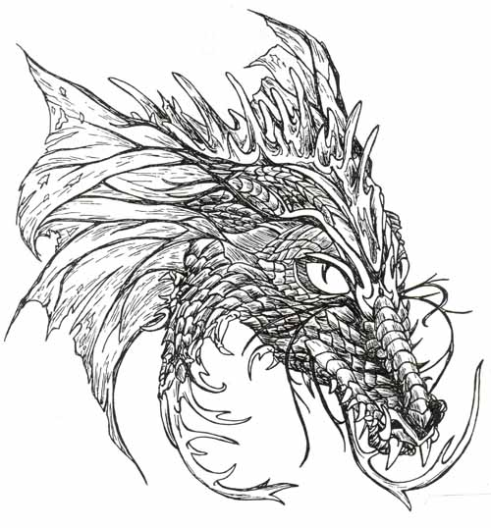
When I woke up the following morning, I was sure the events of the day before had been merely a vivid dream. I wolfed down my breakfast and hurried out, expecting to see just the winter’s first snow. But she was waiting for me by the den entrance, clear of snow but as beautiful as ever. The world around us had been transformed into a winter paradise of shockingly bright carpet of fresh snow and all the bare branches were covered in a delicate icing of new frost. My pulse quickened as I looked into her warm eyes and I was finally certain that she was not merely a figment of my lonely imagination. As it was, I could not wait to spend the day with her.
She seemed somehow satisfied now that I was outside with her. She stamped her huge hooves against the ground a few times and then lifted her head high, letting out a commanding neigh. Almost instantly I felt a strong gust of wind around me as the northern wind answered the summons of Winter. She turned away from the gale and rearing high breathed out a cloud of air so cold I could hear the tingle of the tiny snow crystals. The wind took hold of the frost cloud and carried it far beyond my home forest, leaving ice and snow in its wake.
Her task finished, she walked to an old tree stump by my den and tossed her head to indicate that I should climb on her back. I had never been astride a horse before, magical or otherwise, but with her it was easy. Her wide back offered a comfortable seat for me and she had plenty of mane into which I could sink my paws for added support. Her gaits were soft and even and soon I was no longer clutching her mane with my paws. I stopped worrying about the considerable distance from her back to the ground and shifted my eyes to take in the wintry scenes we were slowly passing. When we reached the frosty plains and she speeded to a slow canter, I could no longer hold back a wild whoop of joy. Hearing my howl, Winter moved effortlessly to a gallop and we flew across the plains like a silver arrow. Clouds heavy with snow trailed behind us and hid the forest in flurries of falling flakes.
She took me far away from my den that day and in those following, showing me new lands and bringing the frost and snow with her wherever we went. She regularly summoned the four winds to carry her season beyond our reach and the northern lands slept under a thick cover of snow. We climbed high into the mountains, exploring hidden valleys and marvelling the view from the roof of the world. We crossed lakes and rivers and the waters froze over underneath her feathered hooves. We observed from a distance as the last flocks of migratory birds headed south and watched as bears hurried to their dens for hibernation in the falling snow. My grey and white winter coat blended in with hers and we passed through the world unseen.
My love for her knew no bounds. Mind you, it was not romantic love, for I was just an ordinary wolf and she a being of magic. It was more as if I recognised something in her, something that I had been unconsciously looking for my entire life. No words were needed between us, we only spoke with look and touch. How she had come to find me, I do not know. Perhaps my loneliness had resonated across the frozen world and guided Winter to me, or perhaps it was the other way round. On the day I found her on that small clearing, maybe it was I who had responded to her silent calls. I think once a mortal lifetime Winter got so lonely she sought a companion to ease the ache in her heart. I was honoured to have found my soul mate.
She stayed with me the whole winter and it was the best time of my life. While wolves were generally pack animals, I had always been a loner but now my few friends saw even less of me. Winter always faded into the blue shadows when others were around and so I tended to avoid everyone so as to just be with her. I did speak with the elder folk enough to find out that the winter was coldest and snowiest anyone could remember. This was hardly surprising, for this year Winter herself blessed the forest with her presence. Every day she sent frost and snow with the winds to all directions, but there was nevertheless plenty left over for our forest. I had never been happier.
Then came the inevitable day when my winter paradise came to an end. Winter had been nervous for some days, summoning the winds with increasing impatience. But that day, even when her voice was filled with rage and command, the north wind did not come. The wind was blowing from the south and we could both smell warmth and rain in that breeze. Winter’s powers over the winds had faded and they now obeyed a different master. She looked at me with her grey eyes full of sadness and I felt a similar pang of grief within me. We had both known that spring would come eventually, but we had tenaciously refused to dwell on it, preferring to enjoy each day together in full. As she rested her heavy head against my shoulder, I knew that it was time for her to go. She was a creature of snow and frost and could not stay to face the warmer seasons. The seemingly endless sorrow in her eyes also told me that she would not be returning here next winter. Perhaps she was only allowed to seek the comfort of another being once a lifetime. It seemed like such a cruel fate and all I could do was clutch pawfuls of her mane as I hugged her close to me and repeated over and over how much I loved her. Far too soon she stepped away from me and letting out a neigh full of sadness, she left me standing alone amidst a winter scene from a fairytale. I collapsed to the ground and wept inconsolably, as I felt my heart break into millions of pieces.
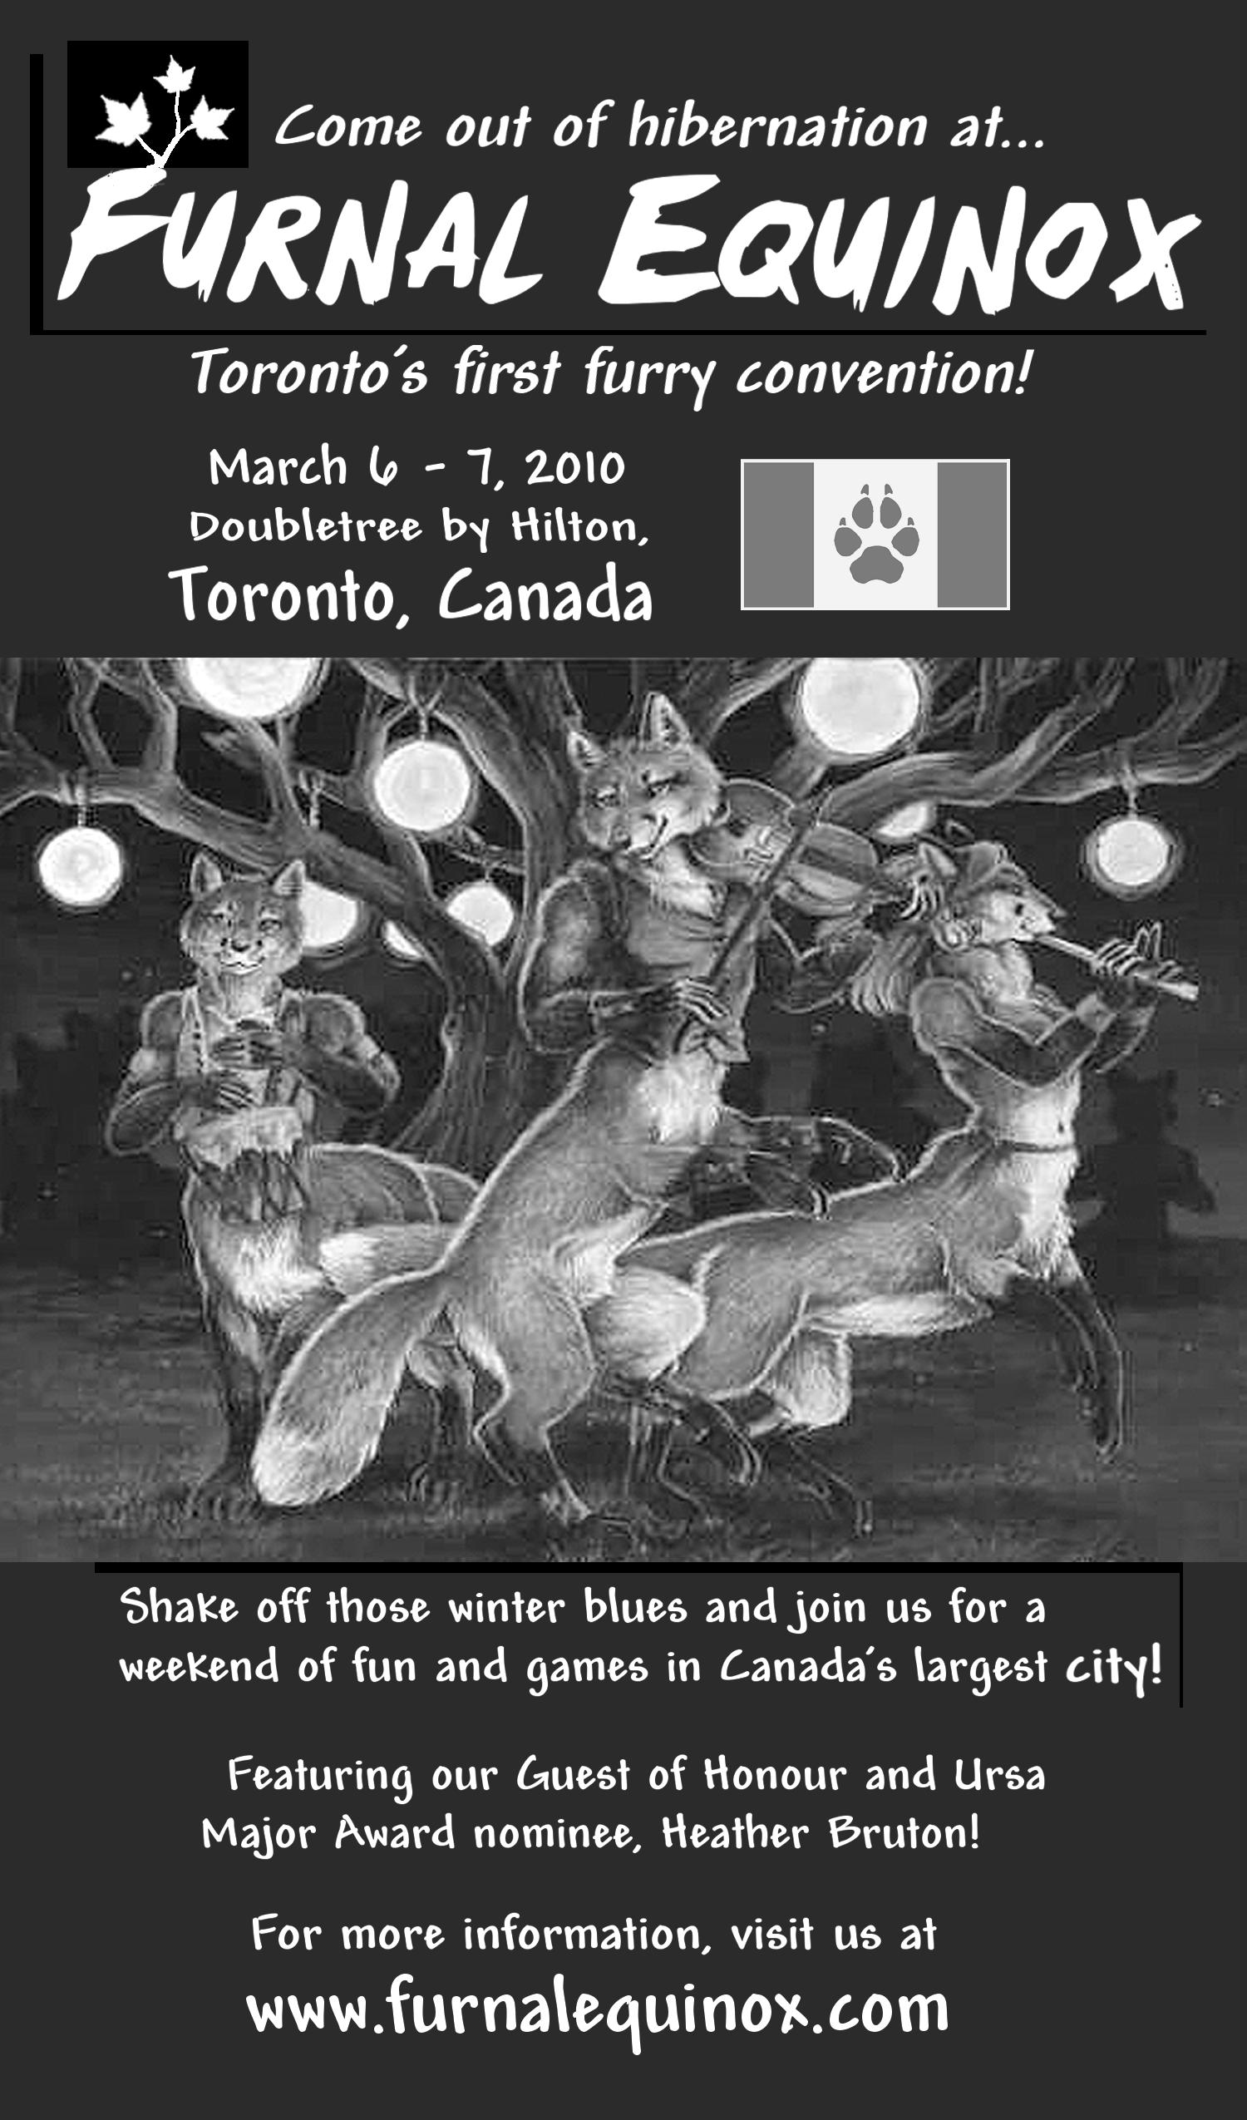
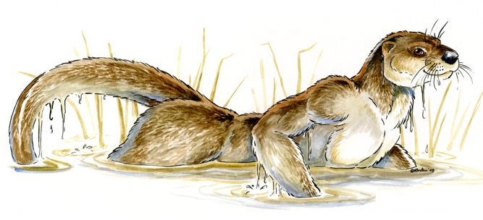
I doubt anyone has ever greeted spring with as much impotent rage as I did that year. As the snow melted and the world was born anew, I sunk into black depression. I stayed in my den, barely ate or slept, and just grieved for my lost soul mate. It is likely that my depression would have killed me, had I not found that Winter left a little bit of her magic behind. I was fetching water one day, when I found tiny hoof prints near my den. My curiosity piqued, I followed them to a meadow, where I found a daffodil yellow foal chasing butterflies. He looked so joyous that I smiled despite myself. Part of me detested him, for he was the one who had banished my beloved Winter. But that he was able to make me smile, even for a brief moment, told me that my life could and would go on. Although I would always be aware of my loss, my broken heart would not kill me. Part of me wished it would, but a greater part stubbornly believed that even without my Winter, life might have more to offer.
I never saw Winter again, but I did catch glimpses of the others as the seasons passed. Spring remained forever a young foal, frolicking across fresh green meadows on gangly legs. Birds, bees and butterflies seemed utterly enamoured with him and he left spring flowers in his wake wherever his hooves touched the ground. Summer blended perfectly into the rich greens of a summer forest. Instead of mane, she had waves of ivy cascading down her neck and she carried a distinct scent of earth after rain about her. No animal feared her and she would often pause to inspect a fox cub or a newborn fawn. Autumn pranced through the forest with the air of a sudden thunderstorm. His copper coat flashed in the sunlight and he seemed to have endless clouds of brightly-coloured dry leaves whirling around his hooves. Wherever he went, apples turned rosy red and bee hives dripped with honey. They were all magnificent creatures, but their beauty did not touch me as Winter’s had. I never tried to approach any of them and they never showed any sign of acknowledging that I could see them. We followed parallel paths that never crossed.
Now I am an old wolf, with poor eyesight and stiff joints. I never stopped missing Winter, but the months we shared are stored in my memory as fresh as ever and they have left a precious imprint upon my soul. I have led a quiet, content life, although no earthly love could have ever come close to how I felt about my soul mate. Even now I venture out on nights so cold that my breath forms tiny ice crystals on the tips of my fur, when the forest is lit by millions and millions of stars. I wander through the woods, oblivious to the fierce cold, until I reach the end of the forest where the plains begin. I can almost see my younger self and Winter speeding across the frozen land. The mountains are too far for me to reach on my own, but I turn to look upon them anyway. I raise my nose toward the stars and let my howl travel through the frozen air. I howl so that somewhere a horse the colour of snow and shadows moving tirelessly through winter landscape may know that there is someone, somewhere, who loves her forever.

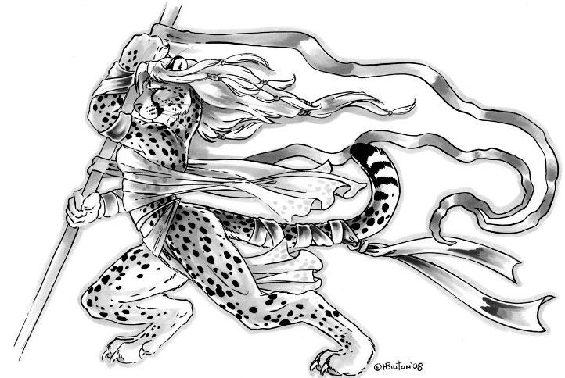
ThisteDealer's List
Volunteer Signup Form

Convention Committee

BLINDSIGHT (co-chair, logistics): Padding into the room, the white wolf fixes you with lambent yellow eyes, and you know without words that here is a pack alpha, confident and in control. Blindsight’s muzzle may be grey, but he’s not been in the fandom that long. He finds it a comfortable place, one that keeps the therian flame within burning. He’s bringing his decades of business and engineering experience to organizing Furnal Equinox, and truly hopes everyone who comes will find something to their liking, and will help to make this a recurring event.
PAKESH (co-chair, gaming): The Pak as he is usually called or the guy with the canadian cola has been working conventions for decades starting back in the early 90's for Toronto Trek to GenCon. Usually harmless at the age of greymuzzle in terms of age and time in the fandom. If bothered he usually is armed with spare cola, hugs, and a friendly attitude. Feel free to poke the ChairBear if needed just to be social. Is very happy to talk games! till your ears fall off so be warned. Current goals in life are to make this con grow up to be a big boy, find the last missing Avro Arrow,and replace his blood with canadian coke
Arctic (security): Known as 'Arcticwolf' at many cons and 'Arctic Fox' on Second Life, Arctic is, in spite of his frosty-sounding name and role as head of con security, quite the amicable, approachable individual! He is a charter member of Anthrocon and brings a wealth of experience to our event, having served as staff, security, and on the board of directors for over twenty furry conventions both in Canada and the United States. Arctic is an avid writer, roleplayer, aficionado of quality ale and ethnic food, and has been a member of the fandom for longer than he usually likes to admit.

ARROWROOT (artists, dealers, merchandising): A young artist working hard to pave her way into the illustration industry which includes her current 2010 web comic project. This of course means she has helped out in some way shape or form for anything art related in the con. If you want to talk to her about the con or about art related things you can find her around the dealers.

CRASSADON (dance, hotel, videogames): You're resident raver wolf, Crassadon, is here to cause loud music to be played at odd hours of the night, and video games to be played at just plain all hours. So give him a hug, and say "hi," when you see him; he should be easy to find: look for the guy with rose coloured glasses.
FLUFFY, MR (mascot): Soft, fluffy and a great friend.
MORGAN (fursuits and panels): Horses. They're prey, and oh very so often eaten in this furry predator dominated fandom. At least Morgan (both his name and his breed), your resident panel organizer and fursuit organizer (and fursuiter) has managed to avoid this fate for forty-four years and counting! And, between hiding and fleeing, he even has time to organize, run panels, make fursuits, and write stuff that is even sometimes published. If you can find him, and if you don't want to eat him, feel free to hug him, or just say "Hey!"
SHANE (volunteers, registration, forums): Cute, fluffy, feral black wolf. 35 years old, speaks his mind. Look for the black Fedora with the wolf on it. Furry since 1996.
SCANI (PR, financial, legal, website): "It's a gryphon! Get halfway in the car!" It's his first ever kick at con planning... and a lot of his work has been from an igloo up in his homeland of Northern Ontario! He's presently a 21-year-old university student and very-part-time writer and musician who's been active in furry communities serving Toronto and Canada for six years... and whose favourite games are Apples to Apples, Rock Band, and euchre. Feel free to say hi (and even give hugs), as it's one of the few opportunities to see him in Toronto .

Thank You Lists

Code of Conduct

Introduction
Our first and foremost goal here at Furnal Equinox is for all of our attendees - including you - to have fun and walk away with great memories of the weekend.
To ensure that nobody's experience is less than it could be, as well as to ensure a good relationship with our host hotel, guests, and the general public for future years of the convention, we've developed this Code of Conduct that is largely in line with the policies of other conventions. The rules given here are meant to be examples, not an exhaustive list of dos and don'ts - any behavior that negatively impacts other guests, the operation of the convention, or our relationship with the hotel will result in action being taken against those responsible. These may include warnings, revocation of con membership, a ban from future events and/or reporting to the police depending on its severity.
By accepting the terms of conduct on the pre-registration page, or by accepting a convention badge, you agree that you are familiar with this Code of Conduct and agree to be bound by it for the duration of your stay.

Identification and Badges
To be issued your convention badge at registration, you must present proper government-issued photo ID that provides proof of identity and age, such as a driver's license, photo health card, or passport (original documents ONLY!) Personal information is collected in accordance with our privacy policytwill be kept confidential. There are no exceptions - failure to present proper ID, or presenting fraudulent ID, will result in refusal to issue a badge and being asked to leave the convention area.
Once you have your convention badge, you must keep it on your person at all times in con space - badges are not transferable under any circumstances. Volunteers and staff may request that you show your badge for admission to convention areas. If for any reason you are ejected from the convention for violating the code of conduct, your badge must be forfeited.

Underage Attendees
Attendees who are under 18 years of age as of March 6, 2010 may attend on the condition provided that they present the Parental Consent Form at registration prior to being issued their convention badge. This form must be signed by their parent or legal guardian. Underage attendees will be issued a badge that provides access to all areas of the convention except those clearly marked and controlled by convention staff as 'mature'.
Individuals who are under 15 years of age must attend under the direct supervision of their parent or legal guardian, who must be with them at all times. The adult under whose supervision they are attending the con must sign the statement on the parental consent form which states said minor must not be left unattended at any time while in convention areas - this gives us a record of who is (supposed to be) legally responsible for looking after the children. Registration will note the adult's con badge and verify their identification when all concerned are present.

Keeping the Con "PG"
All convention space is designated as suitable for general audiences (i.e. PG rating), except for space clearly marked as 'mature' and controlled by convention staff. Attendees should therefore keep issues like the following in mind when it comes to maintaining the "PG" content level. If you have to think twice about what you're doing...it's probably not PG! So please observe these rules:
- Artists and dealers must have "figleaf" stickers over the naughty bits of any explicit artwork, or keep such pictures in a "mature" portfolio and check badges before allowing this to be viewed.
- Attire and costumes should not be unacceptably revealing or indecent (considering the weather in Toronto during this time of year, we don't recommend it anyway!)
- While collars are acceptable as furry fashion statements, leashes are permitted only as part of costumes. Anything more suggestive (fetish wear and demonstrations, etc.) is not welcome in convention space.
- Public displays of affection should be limited to what you'd show in polite company. Hugs are definitely not a problem, but tongue-tangos and beyond should definitely be done in private.
Though we do not plan any interruptions in programming during the overnight hours, we ask for noise in the lobby areas and hotel rooms to be minimized after 11:00 PM, and especially after the dance ends at 2:00 AM. Please note that we will NOT allow anyone to sleep in convention space for security reasons.
Be courteous to your fellow attendees and make sure to keep yourself clean before venturing into convention space...don't make us use soap and cold water on you! This is especially important considering recent worldwide public health concerns (i.e. H1N1).
Harassment of other individuals - i.e. ANY behavior that attempts to intimidate, frighten, or coerce someone in a way that is known to be unwelcome to that person, whether physical or verbal - is not permitted under any circumstances whatsoever. If you are being harassed and telling the individual to desist has not been successful, please report it to staff immediately.

Hotel Matters
Ultimately, this is the hotel's space, and we want to be able to use it in future years. Please show the hotel staff, security, and property all the respect that you can!
If you're staying at the hotel, make sure to leave your room as close to the condition that it was in when you entered it - that includes cleaning up any refuse, making sure hotel property remains undamaged, and the like. Fire regulations also mandate that no more than four people share a room for sleeping quarters - we ask that attendees hold to this.
Be considerate of non-convention guests in the hotel and avoid disrupting any other events in any way, shape, or form - including keeping noise to a minimum at all times, especially during room party events. The hotel has a noise curfew after 11:00 PM which must be observed, so make sure your parties are in "quiet mode" after this time. Hotel and convention staff will cooperate in giving violators ample warning before more drastic action is taken, but you will only get one warning before your event is shut down.
Above all: please note that the individual renting the room is fully responsible for all events occurring in the room for the duration of his or her stay. If a room party gets out of hand, regardless of whether the renter is the one running the event, the renter is responsible. If there is damage to hotel property or excessive trash in your room, the renter is responsible. This responsibility is both to the hotel (in the form of restitution if needed) and the convention (in terms of forfeiture of membership.)

Alcohol, Smoking and Other Substances
Alcohol will not be provided and is not allowed in convention space. If you do choose to drink in private, please enjoy responsibly, and if you leave the convention after drinking, make sure to seek alternative transportation - don't drink and drive.
Please note the legal drinking age in the Province of Ontario is 19. Despite this age being lower than our US counterparts, it is absolutely forbidden to consume alcohol if you are underage, or to provide alcohol to individuals who are underage; both by convention policy and Ontario law. Failure to abide by this will result in revocation of your con membership and referral to the police - be warned, the penalties are stiff!
Smoking is prohibited in convention areas or anywhere in the hotel per City of Toronto municipal by-laws and the Province of Ontario's Smoke-Free Act. Individuals who wish to smoke should do so outside the building, at a sufficient distance from the hotel. Please be considerate and make sure to dispose of cigarette butts too!
The use, distribution, or trafficking of any illegal drug or controlled substance per the Controlled Drugs and Substances Act is a federal offense and will result in the revocation of convention membership and report to the police.

Pets
Please don't bring your pets into con space for the protection of the animal and attendees. Service animals (guide dogs and the like) are always welcome.

Weapons
Bringing any sort of weapon into con space is strictly forbidden as it presents a massive liability issue for our event. Weapon replicas that are intended for use as part of a costume must be brought to security for peace bonding before being used in convention space. They must be appropriately secured and inaccessible (i.e. in a case) when not in use.

Transactions
Sales of merchandise may only take place in the Dealers' Den or at artist's tables in the lobby. Dealers assume ALL responsibility for adhering to Ontario laws for retailers, including obtaining a Vendors' Permit and the collection of sales taxes if applicable to your business, and must provide evidence of having complied with said requirements upon request.
Media
Furnal Equinox's attendees are permitted to take photos and video recordings of convention events and attendees for their own personal and non-commercial use, as long as the consent of other individuals featuring prominently in said media is obtained (however, we will not intervene in disputes that arise over this). Photographs of any type (including cellphone camera use) are not permitted under any circumstances in dealer space, however, as this may result in violation of artist's copyrights.

